Scheduling Project
Architecture/Design Document

Table of Contents
1 Introduction 3
2 Design Goals 4
3 System Behavior 4
4 Logical View 5
4.1 High-Level Design (Architecture) 5
4.2 Mid-Level Design 6
4.3 Detailed Class Design 8
5 Process View 11
6 Development View 12
7 Physical View 12
8 Use Case View 12

Change History
Version: 1.0
Modifier: Anisha, Nawaf, Daniel and Stanley
Date: 4/3/2020
Description of Change: Architecture document rough draft created of Scheduling Project
______________________________________________________

Introduction

UMKC School of Computing and Engineering is a diversified community with students all around the world. Depending upon the schedules of the students, classes are varies which has affected Professors availability and classrooms accordingly.
The main purpose of this project is to make schedule reliable on both students and professors checking their availability time along with the classrooms. We are trying to make scheduling system so that none of the class time, classrooms and professor time overlap with one another. The schedule system should be under the requirements policy of UMKC.
A second problem or opportunity address by the proposed project is to make students familiar with programming language like python, C++ and prepare and develop skills for the industry world. Also, it emphasizes to build our communication skills and leadership skills. Lastly, making us familiar with technical terms like pushing the assignment through GitHub, unit testing, bug fixing, and iteration.

- Users and the customer – they want assurances that the architecture will provide for system functionality and exhibit desirable non-functional quality requirements such as usability, reliability, etc.

- Developers – they want an architecture that will minimize complexity and development effort.

- Project Manager – the project manager is responsible for assigning tasks and coordinating development work. Our project team members want an architecture that divides the system into components of roughly equal size and complexity that can be developed simultaneously with minimal dependencies. For this to happen, the modules need well-defined interfaces. Also, because most individuals specialize in a particular skill or technology, modules should be designed around the availabilities of students and professor. For example, all UI logic might be encapsulated in one module. Another might have all business logic.

- Maintenance Programmers – they want assurance that the system will be easy to evolve and maintain on into the future.

The architecture and design for a software system is complex and individual availabilities of students and professors. At the minimum, the software will allow users to create constraints with varying priorities for individual professors and allow the user to place professors and classes into a schedule and determine if any constraint is violated. The scope can be extended to generating the best-fit schedule with least amount of constraints violated.

The architecture and design of this scheduling project are relatively simple. A view of the project architecture has been prototyped.

- Logical View – major components, their attributes and operations of the scheduling system. This view also includes relationships between components and their interactions. When doing ER diagram, class diagrams and sequence diagrams are often used to express the logical view.

- Process View – the threads of control and processes used to execute the operations identified in the logical view.

- Development View – how system modules map to development organization.

- Use Case View – the use case view is used to both motivate and validate design activity. At the start of design, the requirements define the functional objectives for the design. Use cases are also used to validate suggested designs. The components should have all the necessary behavior to conceptually execute a use case for scheduling system very effectively and efficiently.

Design Goals
The general goal of the project is to create scheduling system to run effectively tracking the class ID, class time, Professor availability and classrooms within SCE department. More specifically:

- The system should be useful. It should provide information about different class time for students.
- The device should be convenient and easy to use. It should require no overlapping time schedule within two different professors. Use of the system should not cause frustration or confusion for students during their enrollment time when selecting the class time and the courses and professors to pick time where number of students can make able to enroll for the class.
- The system should offer at least provide option to students to choose two different times for one class. The system should include at two modes: day class time mode and night class time mode. For the daytime mode, students and professor can choose daytime for their classes and for the night time mode, students and professors can choose night time for their classes according to their availability.

System Behavior
The use case view is used to both drive the design phase and validate the output of the design phase. The architecture of the system should demonstrate the great use of web application and language preference to code the system. It should also demonstrate the capability of unit testing and fully implementing the code for the full range of user preferences. The design and implementation should make it easy to fully implement this feature in the future by UMKC faculty members, staffs and students.

Logical View
The logical view describes the main functional components of the system. This includes modules, the static relationships between modules, and their dynamic patterns of interaction of the scheduling system.

In this section the modules of the system are first expressed in terms of high-level components (architecture) and progressively refined into more detailed components and eventually classes with specific attributes and operations.

High-Level Design (Architecture)

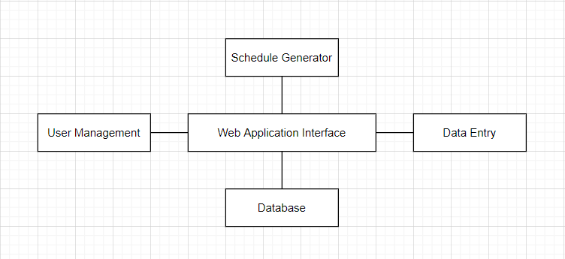
- The Database is a central repository for data on professors, classes, and buildings.
- The Schedule Generator generates a best fit schedule using the user’s inputted data or constraints professors entered themselves.
- The Data Entry level interacts with database and allows a permitted user to alter information in the database through the UI. This is necessary for schedule generator to operate properly.
- The User Management level makes sure the users that only permitted users have access to certain parts of the application and allows professors to enter their own constraints.
- The Web Application Interface is the main driver of the web application and performs action specified by the user.

Mid-Level Design
The diagram below shows the two workflows between a schedule creator and professor and the different application interaction that both allow.
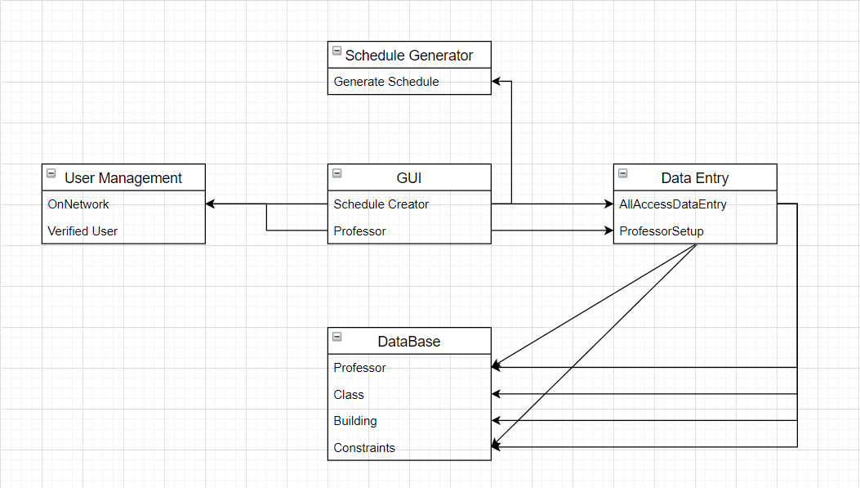

Detailed Class Design
Provided is a detailed ER diagram showing relationships between classes, but still contains relevant information. These classes contain the core attributes needed for schedule generation and will not have any underlying methods in each. The business layer and schedule creator will use these attributes when creating a schedule.

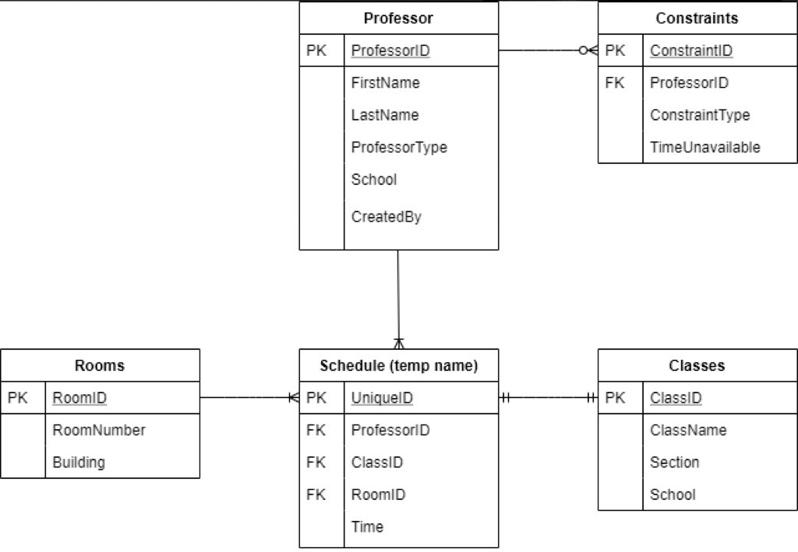

Process View
Schedule Generation will feature a backtracking algorithm that will continue to run as the best fit schedule is created. User Management and verification will need to be continuous as well to combat people accessing information who should not have access.

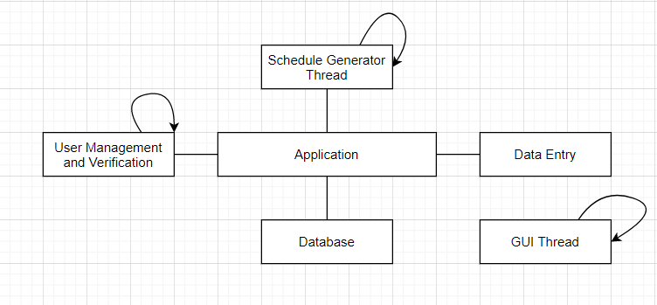

Development View
We will be applying annealing scheduling to obtain the most accurate generated schedule. The algorithm will take the data from the database connected to the website on Django and use them as constraints to generate a schedule that fits all the class requirements. One of the main concerns is the initial temperature for the algorithm. If it starts too low, it may not generate an optimal schedule as the final schedule. It is crucial that the algorithm is accurately returning optimal schedules to ensure system quality.
As far as the UI and other extra components go, these will be made as simple as possible to ensure any type of user, with little to plenty of experience using computers, can use.

Use Case View

The user will access the platform through a browser on any computer capable of accessing the internet. They will be able to access the platform after providing their credentials. They can generate a schedule based on the database constraints. They also can add data to the database using the template as displayed below:
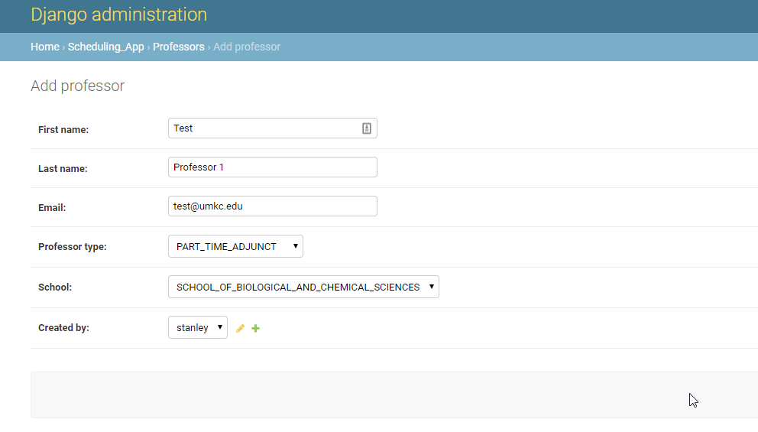
The generation is automated and requires little to no input from the user.

